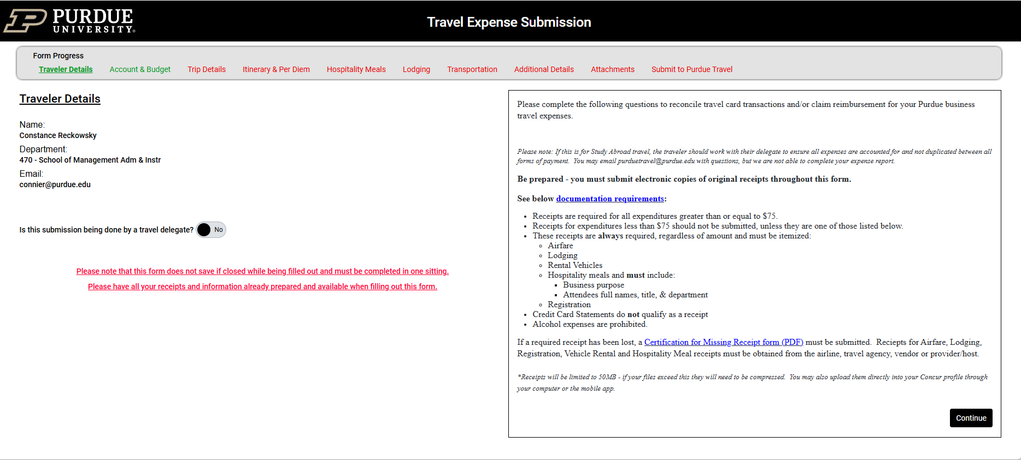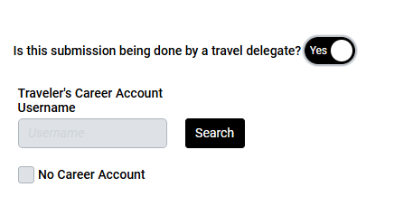
Review the above list carefully to ensure you have all necessary documentation and information before starting.
Submitting on behalf of someone? - Slide the button to ‘yes’ and enter your username and Search, as shown below.
Traveler Details – Your name and information will automatically populate.

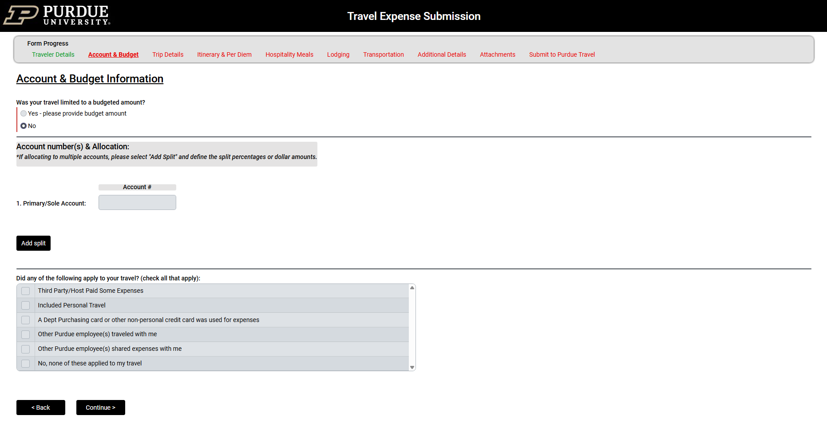
Enter the 9-digit account number to which your trip will be charged.
(there is no search engine)

If you will split the expense between two or more accounts,
click here to add more account numbers and the percentage or dollar amount to charge to each.
Checking one or more of these boxes will prompt you for additional information. Most will ask you for corresponding expenses.

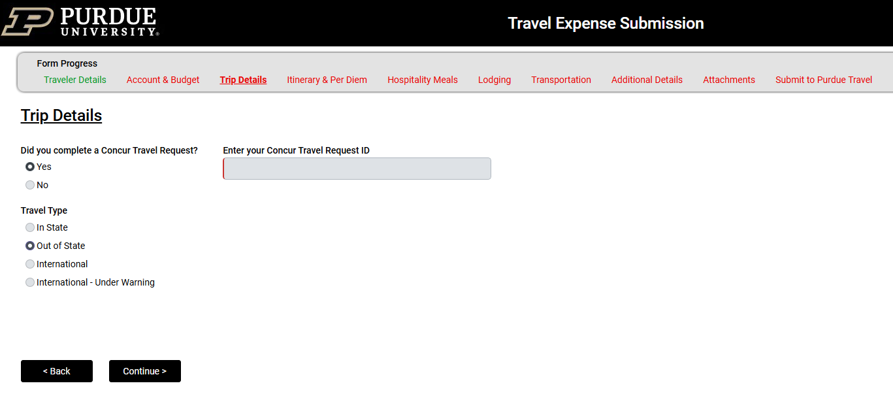
If you completed a Concur Travel Request prior to your trip, click ‘yes’ and supply the request number. If you did not, click ‘no’ and you will be prompted for additional information shown on next page.

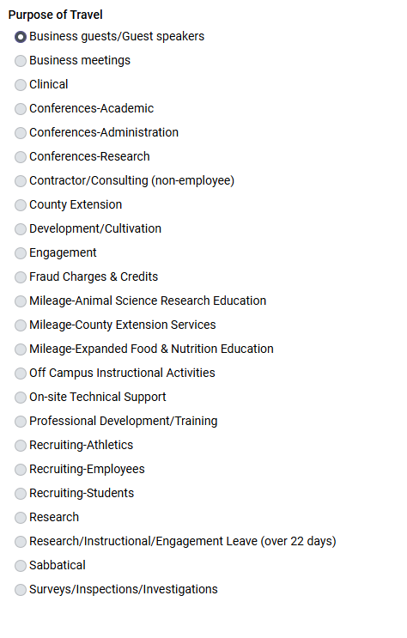
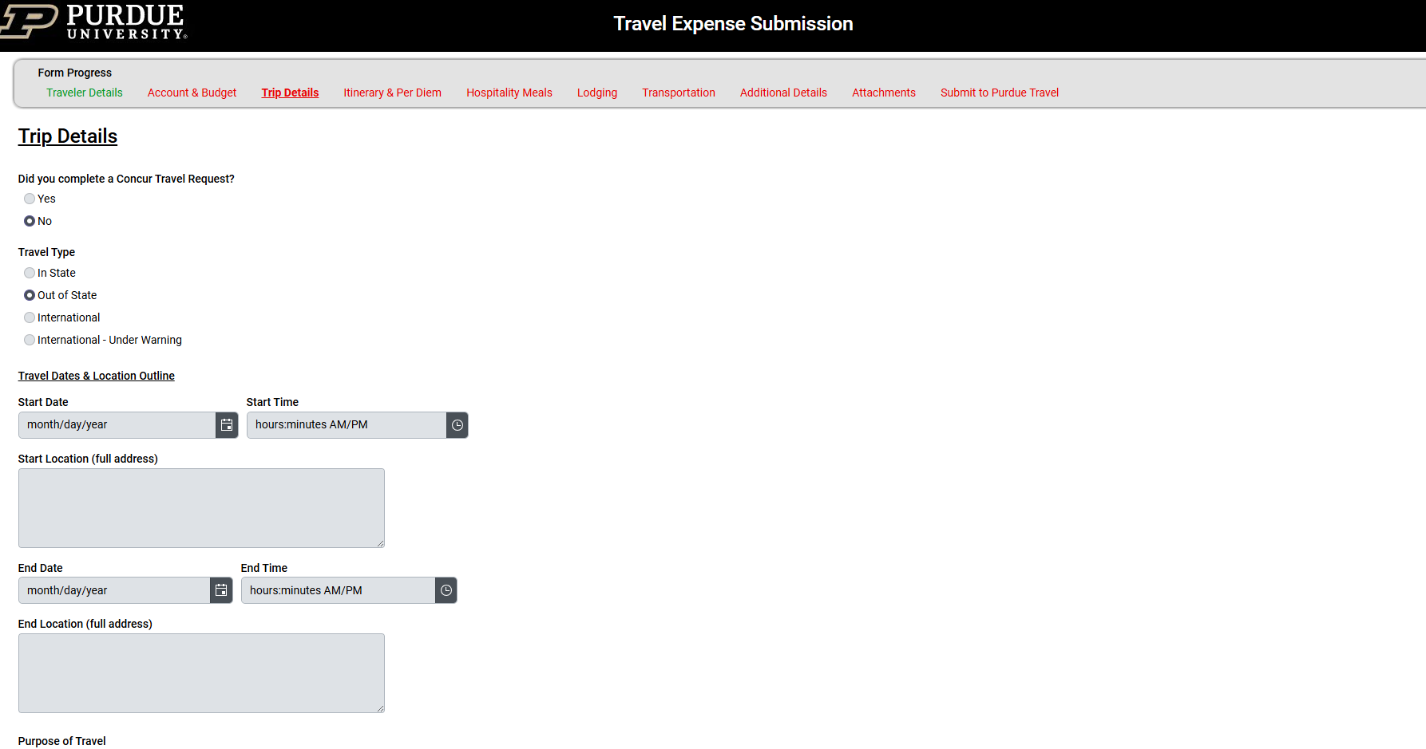
Once you’ve selected the purpose of your travel from the list, additional information may be requested, such as the name of the conference and subsequent receipts.

If you did not complete a Concur Travel Request prior to your trip, your information is collected here.

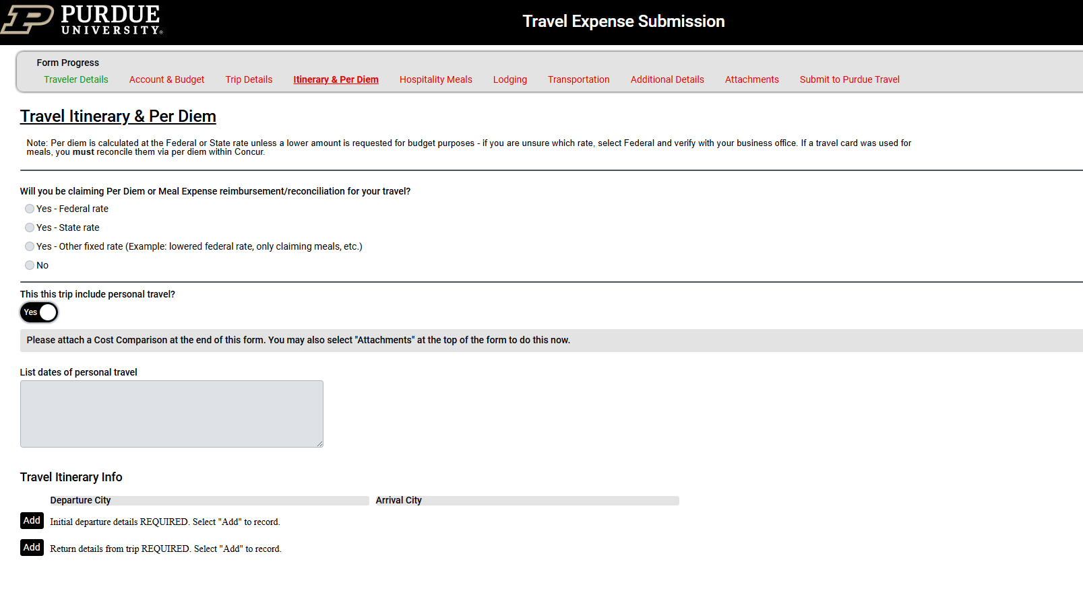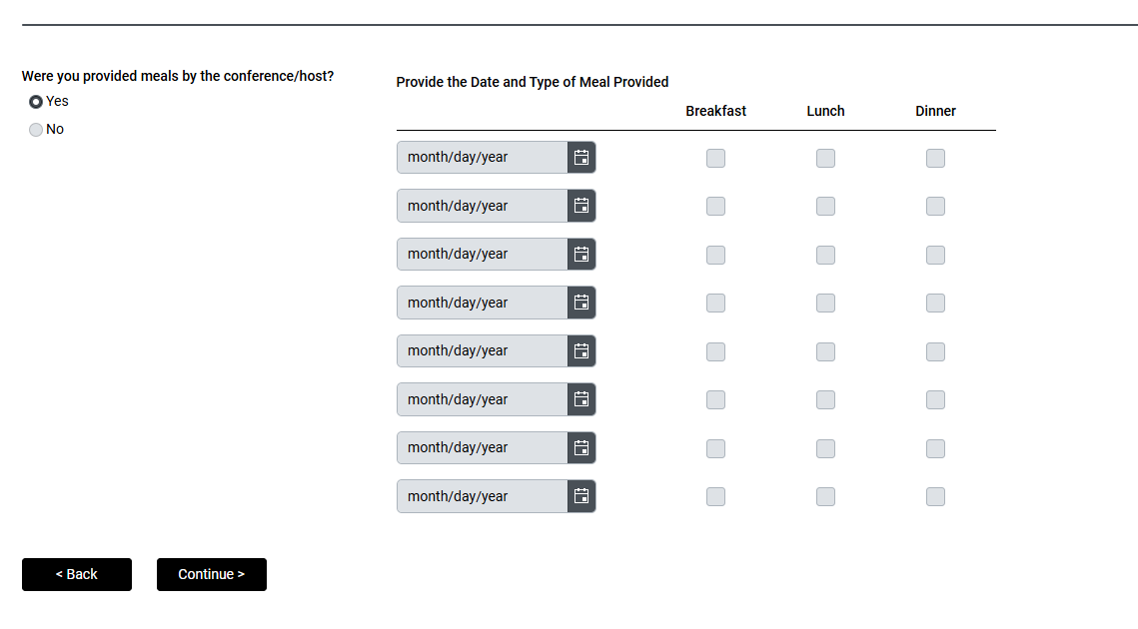
Selecting ‘Add” will bring this box up to provide details for both your departure and return information.

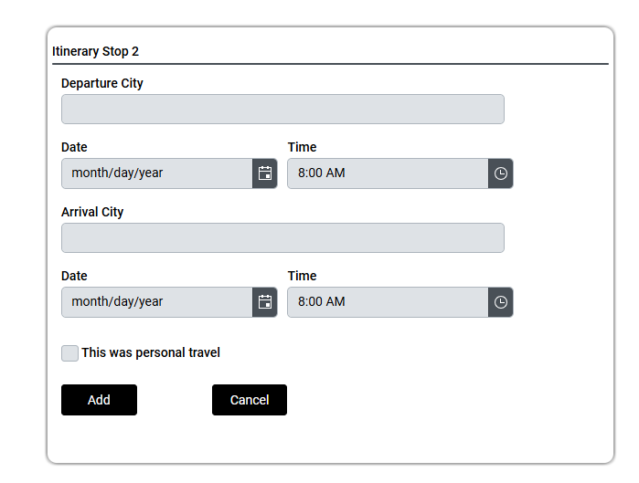
If personal travel was included in your trip, remember to add a Cost Comparison as described here:
https://www.purdue.edu/operations/travel/regulations/cost-comparison-requirements/

If claiming per diem, select ‘Federal Rate’.

If meals were provided, click ‘yes’ and add details for each day received.

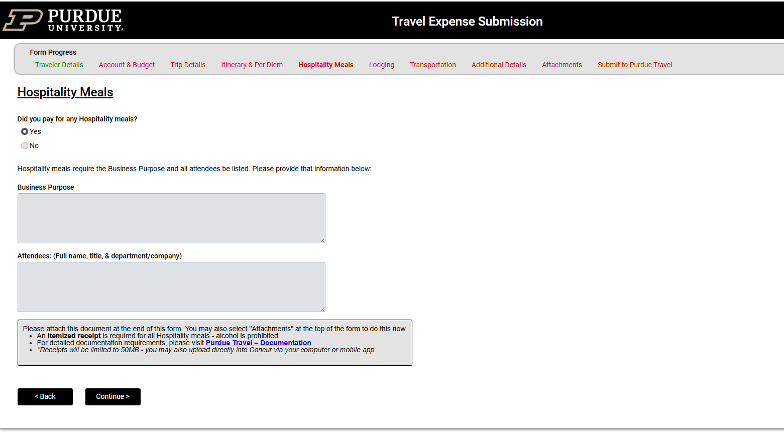
If you paid for a meal for business purposes, click ‘yes’ and provide purpose and attendees.

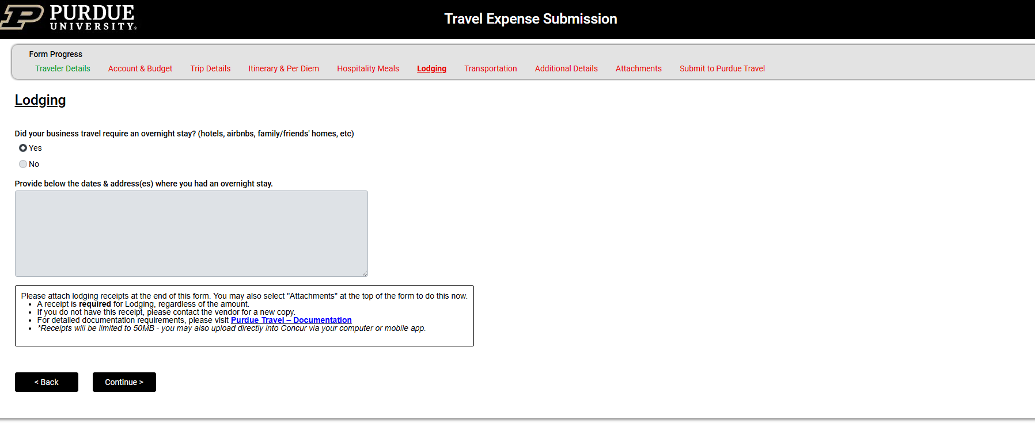
Provide information on any overnight stays.

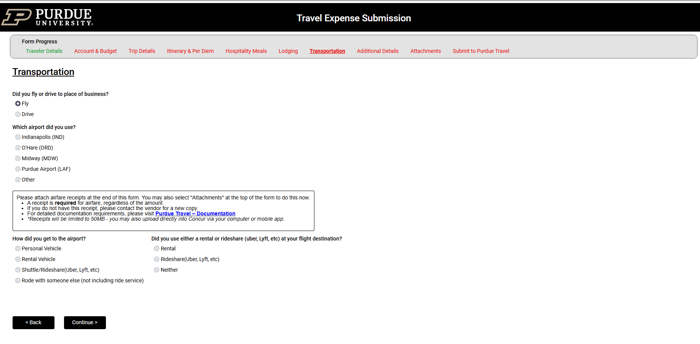
If you selected ‘Fly’, you would see this screen. If you check ‘Drive’ you would see the screen on the next page.

Select Fly or Drive for your travel method.

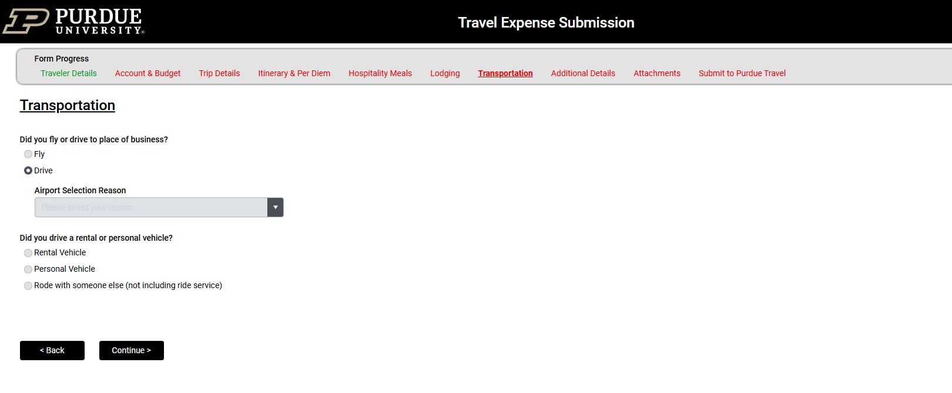
Screen to provide information if you selected ‘Drive’.

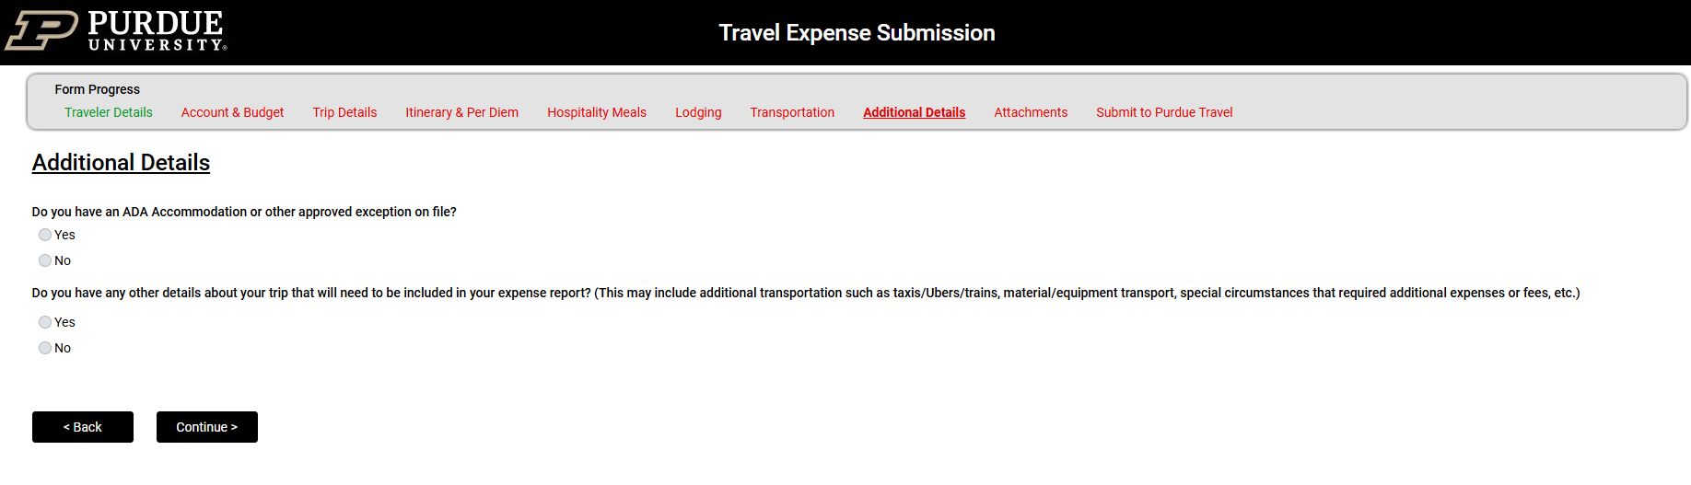
Selecting ‘Yes’ to the second question will prompt you for any incidentals below $75 that you are asking to be reimbursed for. You will not be required to attach the receipts.

Selecting ‘Yes’ to the first question will require you to attach your approved exception document.

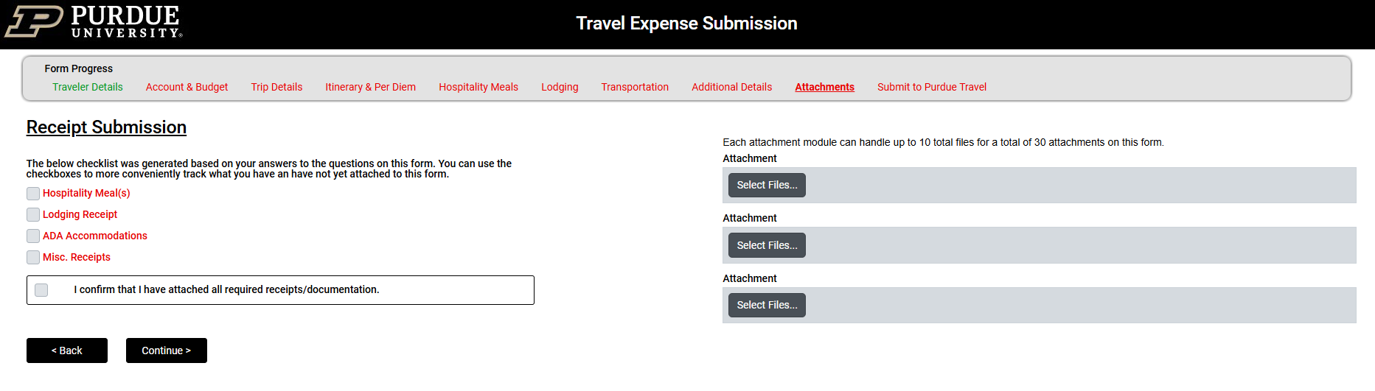

This is where you will attach your travel receipts. These can be attached one-by-one or as a compressed file.

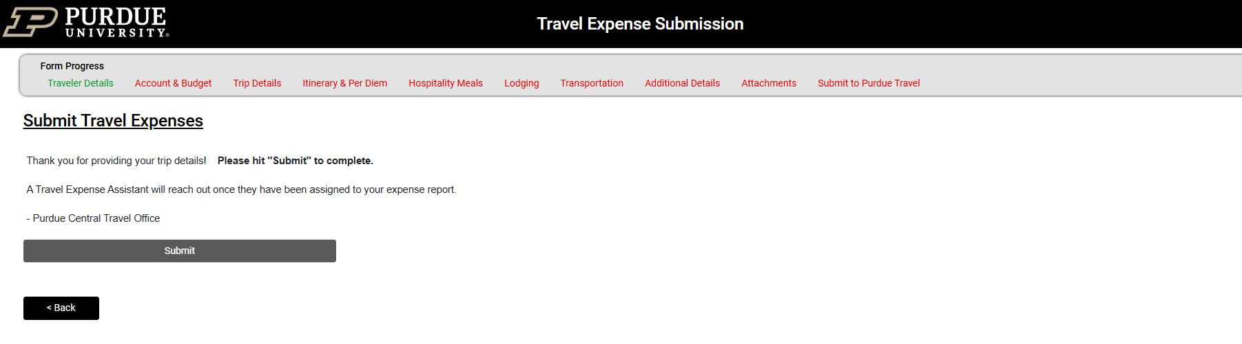
Final page where you submit your travel expenses for reimbursement.

