Can entire departments be burned out?
A conservation of resources perspective on the outcomes of burnout contagion

Working Paper, Purdue University: Please do not cite without permission

Benjamin B. Dunford
Krannert School of Management
Purdue University
403 W. State St.
West Lafayette, IN 47907-2056
bdunford@purdue.edu
(765)496-7877

R. Wayne Boss
Leeds School of Business
University of Colorado at Boulder
Campus Box 419
Boulder, CO 80309
wayne.boss@colorado.edu
(303)494-1718

Alan D. Boss
Business Program
University of Washington Bothell
18115 Campus Way NE
Bothell, WA 98011
aboss@uwb.edu
(425)352-3764

George Zara
Rick Grooms
Providence Hospital
2753 Laurel Street
Columbia, SC 29204
(803)256-5300
Executive Summary
Healthcare managers recognize that burnout can be contagious within work units, disrupting the interpersonal dynamics and performance of large employee groups, even entire departments. Emotional exhaustion can be quickly transferred between employees until the whole department is infected and its functioning is disrupted. However, despite managers’ recognition of the insidious nature of burnout contagion, scholarly research on burnout has been limited mostly to an individual perspective. Some empirical studies have examined burnout contagion within small groups, but have not yet explored contagion within larger business units, such as departments, nor have they examined how shared burnout can impact the actual functioning of departments. Thus, managers have little scientific evidence on which to justify burnout treatment for departments, nor evidence-based guidance from which they might fruitfully develop departmental burnout prevention and reduction interventions.
To address this gap, we draw on the conservation of resources model (Hobfoll 1989) to examine how burnout contagion within hospital departments impacts four critical departmental outcomes: problem solving, interpersonal trust, goal setting, and performance. We tested our hypothesized model in a large sample of employees from a hospital in the southern United States (US), organized into 65 departments. We found strong evidence that burnout was shared at the department level of analysis, and that low burnout departments scored significantly higher than high burnout departments on problem solving, interpersonal trust, goal setting, and overall performance. These findings give rise to a number of useful practical prescriptions for healthcare managers as well as directions for future research on burnout contagion.

Can entire departments be burned out?
A conservation of resources perspective on the outcomes of burnout contagion
Employee burnout is defined as a combination of chronic, long lasting emotional exhaustion, physical fatigue, absence of job involvement, dehumanization of the recipient of one’s services, and lowered job accomplishments (Maslach and Jackson 1981). Burnout is especially problematic in the healthcare industry because of the taxing nature of human service work, and because the consequences of human error are so great (Cherniss 1980; Maslach, Shaufeli, and Leiter 2001). Indeed, burnout research has linked it to lost productivity, medical errors, absenteeism, and turnover (Angermeier, Dunford, Boss, and Boss 2009) and it is estimated to cost employers over $300 billion per year (American Institute of Stress 2002).
Healthcare managers and theorists share the longstanding view that burnout is highly contagious (i.e. transferable) between employees within teams and departments, and that burnout can aggravate entire work units as much as it does individuals (Glasberg, Norberg, and Soderberg 2007). Over 30 years ago, Edelwich and Brodsky (1980) observed that “if burnout only affected individuals in isolation, it would be far less important and far less devastating in its impact than it is. Burnout in human service agencies is like a staph infection in hospitals: it gets around” (25). Emerging research on small teams shows that burnout can vary significantly between teams in addition to varying within them, suggesting that burnout can be a shared phenomenon (Bakker, Le Blanc, and Schaufeli 2005; Garman, Corrigan, and Morris 2002).
Unfortunately, despite longstanding awareness that burnout can be a costly shared phenomenon in larger units or cost centers (Bakker, Demerouti, and Shaufeli 2003; Golembiewski, Munzenrider, and Stevenson 1986), we know of no research that has examined the impact of burnout contagion in large units such as departments, nor how vital departmental functioning and performance are influenced by burnout contagion. In fact, the vast majority of existing burnout research has examined burnout exclusively at the individual level, linking individual employees’ burnout perceptions to individual outcomes such as job satisfaction and turnover (Cordes and Dougherty 1993; Lee and Ashforth 1996). The few burnout contagion studies that do exist have been limited to explaining the development of shared burnout in small teams, and have not yet explored the consequences of burnout contagion (Bakker et al. 2003; Bakker et al. 2005) in terms of performance and group dynamics.
This lack of research on the consequences of department- level burnout is problematic for several reasons. Departments are predominant features in healthcare organizational structures. Most hospitals today organize patient services by departments (Green and Bowie 2005; Wolper 2004) and these departments typically have their own distinct culture and are held accountable for their performance (Shi and Singh 2010). Employees within departments are often interdependent and expected to work together to provide effective healthcare delivery to patients. Accordingly, interpersonal dynamics within departments (e.g., interpersonal trust, communication, cooperation, goal setting, etc.) play a key role in the quality of healthcare delivery (Boss 1989; Klainberg and Dirschel 2010). Thus, an understanding of departmental burnout and its effects on interpersonal dynamics and performance is a key aspect of improving healthcare delivery. Moreover, it behooves managers to take an evidence-based approach to implementing burnout prevention and reduction initiatives. To that end, the purpose of this study is to investigate how departmental burnout impacts four process and performance variables at a large hospital located in the southern US. We begin by describing how burnout is transferred and shared between department members.
Burnout Contagion
Scholars have suggested several reasons why employee burnout is contagious between employees within work units (Cherniss 1980; Edelwich and Brodsky 1980). First, employees within the same department experience many of the same work demands, and have the same access to organizational resources to buffer those work demands, suggesting that they are likely to have similar feelings of depersonalization (Golembiewski et al. 1986). Second, drawing on emotional contagion models (Hatfield, Cacioppo, and Rapson 1994), researchers have argued that burnout can be transferred through a subconscious tendency to mimic the emotions and characteristics of those around them (Bakker et al. 2003; Buunk and Schaufeli 1993). Finally, frequent social interactions, a shared social identity, and task interdependence between department members may facilitate the transfer of burnout (Mason and Griffin 2002).
Drawing on burnout contagion arguments, we define departmental burnout as the degree to which employees in the same department perceive a shared loss of energy and emotional resources preventing them from meeting their shared work demands. Consider for example, an emergency department that is overburdened with demands (e.g., excessive caseload, repeated patients, pressure to reduce costs, etc.). Over time the emergency department’s resources may become inadequate to meet increased demands, leading the entire department to experience higher levels of burnout than other departments in the hospital facing lesser demands. In other words, feelings of shared emotional exhaustion could characterize the department as a whole, and inhibit its functioning. To understand how departmental burnout impacts functional outcomes we draw on the conservation of resources model.
Conservation of Resources
The conservation of resources (COR) model (Hobfoll 1989) is a well-established theoretical framework that explains why burnout develops and how it affects attitudes and behavioral outcomes. Three premises are central to the COR model. The first premise is that burnout is a function of job demands and resources. Job demands are work aspects that “require physical or mental effort, and are therefore…associated with certain costs” (Demerouti, Bakker, and Nachreiner 2001, 501), such as an excessive workload or role demands. Resources are defined as job aspects that are functional to achieving work goals, reducing demands, or stimulating development (Bakker and Demerouti 2007), such as social support and job autonomy. Second, the COR model holds that employees become burned out when they experience or perceive a threat to their resources or when they fail to replenish resources that they have invested in a work related pursuit (Halbesleben 2006). In other words, burnout develops when job demands are greater than the resources available to enable employees to cope (Bakker and Demerouti 2007; Demerouti et al. 2001). Third, the COR model argues that individuals are loss averse when it comes to resources, and facing increased demands, will undertake efforts to conserve or protect their resources (Halbesleben and Buckley 2004). This conservation of resources can take a variety of forms such as withdrawal from co-workers, reduced motivation, and diminished cooperative behavior (Halbelseben and Bowler 2007). In summary, the COR model argues that burnout results when job demands outpace resources, and that a variety of negative consequences arise when employees undertake efforts to conserve emotional resources.
Although the COR model was originally developed to explain the development of burnout and its consequences at the individual level, we propose that it also provides insights into how the interpersonal withdrawal and reduced cooperative behavior associated with departmental burnout can impact an array of departmental process variables and performance. In the following section we draw on the COR model to derive hypotheses about how departmental burnout is associated with four key outcomes: problem solving, interpersonal trust, goal setting, and performance.
Problem Solving
Given the emergence of departments as a predominant organizational form in healthcare organizations (Green and Bowie 2005; Shi and Singh 2010; Wolper 2004), significant effort has been made to make them more effective in solving problems (Boss 1989; Grumbach and Bodenheimer 2004). Problem solving is vital to healthcare delivery and can be especially difficult for departments as they struggle to meet job demands with fewer resources (Heineman and Zeiss 2002). Problem solving is defined as the extent to which department members communicate effectively, make good use of time in department meetings, and are realistic and creative in dealing with challenges (Friedlander 1967).
Drawing on the COR model we propose that departmental burnout can be a significant detriment to problem solving in departments because an imbalance in demands and resources can make department members less cooperative with each other. For example, burned out members may be more withdrawn, focused on their own needs and problems rather than on the needs and problems of the collective group. Departments with excessive demands may be less likely to hold meetings, be attentive to one another, communicate well with each other, or be willing to make sacrifices to overcome challenges. Thus, drawing on the COR model, we hypothesize that:
Hypothesis 1. Department burnout will be negatively associated with problem solving.
Interpersonal Trust
Interpersonal trust has been defined as the extent to which department members “hold trust and confidence in each other” (Friedlander 1967, 295). Multiple theoretical models identify trust as a key aspect of department functioning. Zand (1972) proposed that trust within a work unit creates a reciprocal interaction and mutually reinforcing spiral such that one member’s trustworthy actions can lead to greater information sharing, acceptance of interdependence to unit members, and greater motivation to cooperate. Trust has also been theorized and shown to facilitate problem solving, department interactions, and performance (Boss 1978). Indeed, it has been said that “perhaps there is no single variable which so thoroughly influences interpersonal and group behavior as does trust” (Golembeiwski and McConkie 1975, 131). Interpersonal trust is central to the effectiveness of any work unit, but particularly important in healthcare departments because of their impact on healthcare delivery.
The COR model (Hobfoll 1989) suggests that interpersonal trust is strongly influenced by burnout. As burned out departments seek to conserve emotional resources, they may reduce demands by withholding cooperative behaviors in department interactions. For example, they may be impatient and less tolerant, take longer breaks, and have less desire to do favors for one another (Cordes and Dougherty 1993). These forms of withdrawal are likely to weaken the overall level of interpersonal trust between department members. Thus, drawing on the COR model of burnout, we hypothesize that:
Hypothesis 2: Department burnout will be negatively associated with interpersonal trust.
Goal Setting
Goal setting is defined as the extent to which departments actively set their own goals (Likert 1961). The increasing complexity and sheer volume of responsibilities confronting healthcare departments requires them to clarity and prioritize their objectives, identify measurable outcomes and proactively manage their performance (Grumbach and Bodenheimer 2004). Thus goal setting is a critical part of effective healthcare delivery (Goni 1999). Indeed research consistently shows that work units that take a more proactive role in setting their own goals outperform those who do not set goals. For example, meta-analytic findings show the average performance of groups that set goals is nearly one standard deviation higher than groups that do not set goals (O’Leary Kelly, Martocchio, and Frink 1994).
When departments become burned out, they may be less effective at setting and attaining their own goals for at least two reasons. First, as departments experience burnout they may become so focused on conserving resources and reducing job demands that they fail to invest the time and effort required to set realistic and measurable goals. Second, burned out departments may suffer from reduced collective efficacy, defined as a unit’s “shared perception of its capability to successfully perform a specific task” (Tasa, Taggar and Seijts, 2007, 17). Drawing on the COR model, we propose that departments facing high demands may be less likely to set effective goals because they are less confident in their ability to attain them. Thus we hypothesize that:
Hypothesis 3: Department burnout will be negatively associated with goal setting.

Department Performance

Department performance is widely regarded as essential to the effective performance of healthcare organizations as a whole and to patient outcomes (Boss 1989; Klainberg and Dirschel 2010). In fact, unit performance is considered so vital to healthcare delivery that group performance improvement and department quality initiatives have become mandated by regulatory agencies such as the Joint Commission on the Accreditation of Healthcare Organizations (Heineman and Zeiss 2002). Such improvement issues identify and address numerous threats to unit performance.
One critical threat to department performance is burnout. Department burnout represents a powerful depletion of a department’s emotional resources causing them to be more highly selective in how they choose to expend additional resources (Halbesleben and Bowler 2007). One way that departments can conserve their emotional resources is to focus primarily on performing the tasks which are measured and rewarded by the organization and avoid discretionary behaviors that may be vital to a department’s effectiveness, but not always noticed. Such discretionary behaviors may include doing favors for each other, socializing new members, staying late to finish projects, or going above and beyond the job description. In other words, when confronted with limited emotional resources, departments may do the bare minimum to meet their job responsibilities and eliminate the extra-role behaviors that are unmeasured but vital to performance. Drawing on the COR model, we hypothesize that:
Hypothesis 4: Department burnout will be negatively associated with department performance.
Methods
Participants and Procedure
A 304 bed hospital with 148 departments in the southern US provided the data for this study. Two sources of data were used for this project: an employee opinion survey and structured interviews with department directors. The opinion survey provided the data on employee attitudes within departments which were collected on an individual basis then aggregated to the department level for analysis (see below). The survey was administered online over a two-week period during the summer of 2008, and all employees were asked to participate. We obtained useable responses from 1,455 employees out of a possible 1,613, making our individual level survey response rate 90.2%.
Three months after the surveys were administered, department performance data were obtained from ratings made by department directors in structured interviews with the authors of the study. We chose to interview department directors for this information because they are intimately familiar with the departments they supervise, and thus the most knowledgeable about their performance. We were able to interview 38 of the 75 total department directors. Many department directors supervise more than one department each (average number of departments per director was 1.8, ranging from 1 to 5), thus we were able to obtain performance ratings of 65 departments. Combining the aggregated survey responses with our department level performance ratings our final sample size was 65 departments out of 148 total departments in the hospital, resulting in a department response rate of 43.9%.
On average, respondents to our survey were 38 years-old, with a mean organizational tenure of 3.21 years. Approximately 57% were Caucasian, 36% were African American, 6% were Hispanic and 1% Asian. In terms of education, 13% of our participants had a high school diploma or less, 50% had some college without a four-year degree, 24% had obtained a four-year-college degree, and 13% had graduate work in progress or had received a master’s, professional, or doctoral degree. Our sample consisted of workers representing a variety of functions, including office and clerical workers, support services, professional services, technical services, and nursing.
The departments in this hospital had a mean number of 11 employees each. These departments span administrative, informational, therapeutic, diagnostic, and support functions. As is typical in hospitals, employees within these departments are expected to work together to maximize healthcare delivery. Even though employees within departments span various hierarchical levels (skilled to unskilled) they are largely interdependent and typically interact with each other on a daily basis. They are semi-autonomous in that they are allowed to make certain decisions concerning their work, yet also abide by the centralized policies and procedures set forth by the hospital administration. No significant structural, cultural, leadership, or environmental changes took place in the hospital during the period of this study.
Measures
Independent Variable: Department burnout was measured using the emotional exhaustion component of the Maslach Burnout Inventory (Maslach and Jackson 1981). Responses were recorded using a 5-point Likert scale ranging from “very strongly disagree” to “very strongly agree” (∝ = .93). Although burnout is formally considered a multi-dimensional construct, we followed conventional approaches by focusing exclusively on the emotional exhaustion component because it is widely regarded as the flagship dimension of burnout (Cordes and Dougherty 1993). We calculated department burnout by aggregating the mean emotional exhaustion scores of the individual employees within each of the work departments. To examine the appropriateness of operationalizing burnout as a department level construct prior to aggregation (Bliese 2000), we calculated intraclass correlation coefficients (ICC) on emotional exhaustion. A higher ICC value indicates that ratings on a construct differ consistently across groups. Intraclass correlation coefficients [ICC (1) =.09 and ICC (2) =.55] provided justification for aggregation of the scores to the department level (Bliese 2000).
Dependent Variables: Department problem solving was measured using three items from Friedlander’s Group Behavior Inventory (Friedlander 1967), which is an instrument designed to measure various aspects of group effectiveness. A sample item includes “departmental meetings are effective in discussing mutual problems.” Responses were recorded using a 5-point Likert scale (∝ = .89). Intraclass correlation coefficients [ICC (1) =.10 and ICC (2) =.56] provided justification for aggregation of the scores to the department level.
Interpersonal trust was measured using 3 items from Zand’s (1972) trust scale, designed to assess employees’ beliefs concerning the extent to which they trusted various members of their department, including their peers and their departmental leaders. A sample item includes “Please indicate the degree to which you trust your departmental supervisor.” Responses were recorded using a 10-point Likert scale ranging from “not at all” to “completely” (∝ = .71). Intraclass correlation coefficients [ICC (1) =.11 and ICC (2) =.59] provided justification for score aggregation to the department level.
Department goal setting was measured using the goal setting items from the Likert Organizational Profile (Likert 1967), designed to assess the extent to which employees within departments actively participated in goal setting. The Likert Profile wording was slightly altered so that the department was the referent and not the organization as a whole. A sample item includes “Where is responsibility felt for achieving the department’s goals?” Responses were recorded using a 20-point Likert scale ranging from “mostly at the top” to “at all levels” (∝ = .78). Intraclass correlation coefficients [ICC (1) =.16 and ICC (2) =.70] provided justification for aggregation of the scores to the department level.
Department performance was measured using the following question posed to department directors in structured interviews: “Using the following scale, please rate the overall performance of the _____ department.” This question was repeated to department directors for each of the departments they supervised personally. Responses were recorded using a 7-point Likert scale ranging from “poor” to “outstanding.”
Control variables. We controlled for department size (number of employees per department) and average organizational tenure (in years) within departments because we expected both variables to be associated with departmental burnout and each of the four dependent variables, thus helping to assuage concerns that observed relationships were spurious. Both control variables were obtained from personnel files made available to us by the organization’s Human Resources department.
Results
All study variables were at the department level of analysis, thus, we tested our model using used standard OLS regression. Table 1 reports the means, standard deviations, aggregation statistics, and bivariate inter correlations of the study variables.
[Insert Table 1 here]
To test hypothesis 1-4 we regressed our four dependent variables on department level burnout in four separate equations. We controlled for department size and average tenure in all analyses. The regression results confirmed that department burnout was inversely associated with departmental problem solving, interpersonal trust, goal setting, and performance, after controlling for department size and average tenure. Table 2 reports F and model fit statistics for each equation. Significant associations between departmental burnout and each hypothesized dependent variable are graphically illustrated in Figures 1 through 4. In these figures, departments that are one standard deviation above and below the mean on burnout (respectively) are compared on each of the four dependent variables. As the figures suggest, significant mean differences were observed for each variable.
[Insert Table 2 and Figures 1-4 here]
Discussion and Implications
In a large sample of hospital employees we found strong evidence of department level burnout, such that a significant portion of variance in burnout existed between departments above and beyond the portion of variance observed within departments. This is significant because it shows that burnout can be transmitted and shared across fairly large work units of employees. Indeed, this study shows that burnout contagion is not limited to employee dyads or small groups. To our knowledge, this is the first study that explores burnout contagion at the department level of analysis, which is important because of the ubiquity of departmental organizational structures in hospitals. Moreover, we found strong evidence that departmental burnout is associated with key departmental processes and performance. Mean levels of problem solving, interpersonal trust, goal setting, and performance were all significantly higher in departments that had lower levels of burnout. This supports our theoretical model suggesting that deficits in the balance between job demands and resources may cause employees within departments to curtail their cooperation with one another in various ways, thereby thwarting the effectiveness of the unit.
These findings lead to important practical implications for healthcare organizations. First, healthcare managers should regularly monitor burnout, not only in individuals, but also in business units. This monitoring could be done through interviews or employee attitude surveys to identify departments that are burned out, or at risk for burning out. Once high or at risk burnout departments are identified, interventions could be targeted to treat or prevent the shared burnout. Indeed, research demonstrates that burnout reduction interventions can be highly effective in treating work groups (Le Blanc, Hox, Schaufeli, Taris, and Peeters 2007). For example, employees in high burnout departments can be trained to recognize burnout symptoms, manage their time and stress better, and engage in relaxation techniques. Based on the COR model, we propose that such interventions should be targeted to reducing job demands and increasing employee resources within departments. Figure 5 summarizes our recommendations.
[Insert Figure 5 here]
Limitations and Future Research
Certain study limitations provide boundary conditions for our research findings, but give several directions for future research. First, the generalizability of our findings may be limited because we studied departments in a single hospital. Although our sample consisted of a wide variety of departments and included employees of diverse backgrounds and skills, future research should investigate the impact of unit level burnout contagion on outcomes in a broad range of healthcare organizations.
Second, we did not investigate how burnout contagion develops within departments. Although previous research has studied how burnout contagion develops within teams, the burnout process in departments may differ in meaningful ways. For example, given the larger size of departments relative to teams, it may take longer for burnout to be transferred between employees, or be more contingent on the size of departments, or the nature of the interactions between department members. Future research should investigate what factors may accelerate or decelerate the burnout contagion process in departments.
Third, although our use of department director measures of performance enabled us to use data from multiple sources at two measurement points, some of the study variables were drawn from the same source (survey) at the same time. Thus, we were not able to get a complete picture of how burnout contagion develops over time. Future research should incorporate more sources of data over multiple time periods to study the development of burnout contagion and its effects on departmental performance longitudinally (Cordes and Dougherty 1993).
Conclusion
Healthcare managers have recognized that burnout contagion can be insidious and cause even large units like departments to be dysfunctional. Thus, it behooves healthcare managers to understand how burnout at the department level impacts functional outcomes. Unfortunately to date, the scholarly literature on burnout provides little evidence-based guidance for healthcare managers to develop and implement effective burnout prevention and reduction tactics at the department level. This study provides, to our knowledge, the first scholarly evidence that departmental burnout contagion exists, and shows that it is negatively associated with problem solving, interpersonal trust, goal setting, and performance at the department level. These results provide evidence that healthcare managers should be highly proactive in identifying burned-out departments and in implementing intervention programs to ameliorate dysfunctional interpersonal dynamics and reduced performance.
References
American Institute of Stress. 2002. Job Stress. New York: Author.
Angermeier, I., B. B. Dunford, A. D. Boss, and R. W. Boss. 2009. “The Impact of Participative Management Perceptions on Customer Service, Medical Errors, Burnout, and Turnover Intentions.” Journal of Healthcare Management 54 (2): 127-41.
Bakker A. B., and E. Demerouti. 2007. “The Job-Demands-Resources Model: State of the Art.” Journal of Managerial Psychology 22: 309-28.
Bakker, A. B., P. M. Le Blanc, and W. B. Schaufeli. 2005. “Burnout Contagion among Nurses Who Work at Intensive Care Units.” Journal of Advanced Nursing 51: 276-87.
Bakker, A. B., E. Demerouti, and W. B. Schaufeli. 2003. “The Socially Induced Burnout Model.” In S. P. Shohov (Ed.), Advances in Psychology Research (Vol. 25). New York: Nova Science Publishers.
Bliese, P. D. 2000. “Within-Group Agreement, Non-Independence, and Reliability: Implications for Data Aggregation and Analyses.” In K. J. Klein and S. W. J. Kozlowski (Eds.), Multilevel Theory, Research, and Methods in Organizations: Foundations, Extensions, and New Directions, pp. 349-81. San Francisco, CA: Jossey-Bass.
Boss, R. W. 1978. “The Effects of Leader Absence on a Confrontation Team-Building Design.”. The Journal of Applied Behavioral Science 14: 469-78.
Boss, R. W. 1989. Organizational Development in Healthcare. New York: Addison Wesley.
Buunk A. P., and W. B. Schaufeli. 1993. “Burnout: A Perspective from Social Comparison Theory.” In W. B. Schaufeli, C. Maslach, and T. Marek (Eds.), Professional Burnout: Recent Developments in Theory and Research (pp. 53–69). New York: Taylor and Francis.
Cherniss, C. 1980. Professional Burnout in Human Service Organizations. New York: Praeger.
Cordes, C. L., and Dougherty, T. W. 1993. “A Review and an Integration of Research on Job Burnout.” Academy of Management Review 18: 621-56.
Demerouti, E., A. B. Bakker, F. Nachreiner, and W. B. Schaufeli. 2001. “The Job Demands-Resources Model.” Journal of Applied Psychology 86: 499-512.
Edelwich, J., and A. Brodsky. 1980. Burnout: States of Disillusionment in the Helping Professions. New York: Human Services Press.
Friedlander, F. 1967. “The Impact of Organizational Training Laboratories upon the Effectiveness and Interaction of Ongoing Work Groups.” Personnel Psychology 20 (3): 289-307.
Garman, A. N., P. W. Corrigan, and S. Morris. 2002. “Staff Burnout and Patient Satisfaction: Evidence of Relationships at the Care Unit Level.” Journal of Occupational Health Psychology 7 (3): 235-41.
Glasberg, A. L., A. Norberg, and A. Soderberg, 2007. “Sources of Burnout among Healthcare Employees as Perceived by Managers.” Journal of Advanced Nursing 60 (1): 10-19.
Golembiewski, R. T., R. F. Munzenrider, and J. G. Stevenson. 1986. Stress in Organizations. New York: Praeger.
Golembiewski, R. T., M. L. McConkie. 1975. “The Centrality of Interpersonal Trust in Group Processes”, in C. L. Cooper (Ed), Theories of Group Processes. New York: Wiley and Sons.
Goni, S. 1999. “An Analysis of the Effectiveness of Spanish Primary Care Teams.” Health Policy 48: 107-17.
Green, M. A., and M. J. Bowie. 2005. Essentials of Health Information Management: Principles and Practices. Clifton Park, NY: Thompson Corporation.
Grumbach, K. and T. Bodenheimer. 2004. “Can Healthcare Teams Improve Primary Care Practice? Journal of the American Medical Association 294 (10): 1246-51.
Halbesleben, J. R. B. 2006. “Sources of Social Support and Burnout: A Meta Analytic Test of the Conservation of Resources Model.” Journal of Applied Psychology 91: 1134-45.
Halbesleben, J. R. B., and W. M. Bowler. 2007. “Emotional Exhaustion and Job Performance: The Mediating Role of Motivation.” Journal of Applied Psychology, 92: 93–106.
Halbesleben, J. R. B., and M. R. Buckley. 2004. “Burnout in Organizational Life.” Journal of Management 30: 859-79.
Hatfield E., J. T. Cacioppo, and R. L. Rapson. 1994. Emotional Contagion. New York: Cambridge University Press.
Heineman, G., and A. Zeiss. 2002. “A Model of Team Performance.” In G. Heineman and A. Ziess, (Eds.) Team Performance in Healthcare (pp.29-42). New York: Plenum Publishers.
Hobfoll, S. E. 1989. “Conservation of Resources: A New Attempt at Conceptualizing Stress.” American Psychologist 44: 513–24.
Klainberg, M. and K. M. Dirschel. 2010. Today’s Nursing Leader: Managing, Succeeding, Excelling. Sudbury, MA: Jones and Bartlett Publishers.
Le Blanc, P. M., J. J. Hox, W. B. Schaufeli, T. W. Taris, and M. C. Peeters. 2007. “Take Care! The Evaluation of a Team Based Burnout Intervention Program for Oncology Care Providers.” Journal of Applied Psychology 92 (1): 213-27.
Lee, R. T., and B. E. Ashforth. 1996. “A Meta-Analytic Examination of the Correlates of the Three Dimensions of Job Burnout.” Journal of Applied Psychology 81: 123–33.
Likert, R. 1961. New Patterns of Management. New York: McGraw-Hill.
Likert, R. 1967. The Human Organization, its Management and Value. New York: McGraw-Hill.
Maslach, C., and S. E. Jackson. 1981. “The Measurement of Experienced Burnout.” Journal of Occupational Behavior 2: 99-113.
Maslach, C., W. B. Schaufeli, and M. P. Leiter. 2001. “Job Burnout.” Annual Review of Psychology 52: 397-422.
Mason, C. M., and M. A. Griffin. 2002. “Group Task Satisfaction: Applying the Construct of Job Satisfaction to Groups.” Small Group Research 33: 271-312.
O’Leary-Kelly, A. M., J. J. Martocchio, and D. D. Frink. 1994. “A Review of the Influence of Group Goals on Group Performance.” Academy of Management Journal 37 (5): 1285-1301.
Shi, L. and D. A. Singh. 2010. Essentials of the U.S. Healthcare System (2nd Edition). Sudbury, MA: Jones and Bartlett Publishers.
Tasa, K., S. Taggar, and G. H. Seijts. 2007. “The Development of Collective Efficacy in Teams: A Multi-level and Longitudinal Perspective.” Journal of Applied Psychology 92: 17-27.
Wolper, L. F. 2004. Health Care Administration: Planning, Implementing and Managing Organized Delivery Systems (4th edition). Sudbury, MA: Jones and Bartlett Publishers.
Zand, D. E. 1972. "Trust and Managerial Problem Solving." Administrative Science Quarterly 17: 229-39.

Table 1. Aggregation Statistics, Means, Standard Deviations and Inter-correlations between Study Variables

# | Variable | ICC (1) | ICC (2) | Mean | SD | 1 | 2 | 3 | 4 | 5 | 6 | 7
1 | Department size‡ | -- | -- | 11.51 | 11.81 | --
2 | Organizational tenure | -- | -- | 3.21 | .97 | -.01 | --
3 | Departmental burnout | .09 | .55 | 2.71 | 0.74 | .26* | -.22 | .93
4 | Problem solving | .10 | .56 | 3.40 | 0.61 | -.28* | -.09 | -.51** | .89
5 | Interpersonal trust | .11 | .59 | 7.35 | 1.27 | -.28* | -.11 | -.51** | .81** | .71
6 | Goal setting | .16 | .70 | 11.66 | 1.85 | -.37** | -.08 | -.40** | .77** | .77** | .78
7 | Department performance | -- | -- | 5.29 | 1.10 | -.13 | -.01 | -.36** | .34** | .37** | .38** | --

Notes: ‡in number of employees. **p < .01 (2-tailed). *p < .05 (2-tailed). †p < .10 (2 tailed). N = 65. Alpha reliability coefficients are listed in boldface on the diagonal where appropriate. ICCs are intra class correlations.
Table 2. Regression Results for Department Burnout Predicting Four Outcome Variables

 | Problem solving |  | Interpersonal trust |  | Goal setting |  | Department performance
 | Model 1 | Model 2 | Model 1 | Model 2 | Model 1 | Model 2 | Model 1 | Model 2
Control variables:
Department size | -.28* | -.15 | -.31* | -.17 | -.37** | -.28* | -.13 | -.04
Average tenure | -.09 | .20† | -.04 | -.15 | -.09 | -.16 | -.01 | -.09
Independent variable:
Departmental burnout |  | -.51** |  | -.54** |  | -.36** |  | -.37**
F | 2.90† | 9.50** | 3.23* | 11.31** | 5.26** | 7.06** | .58 | 3.47*
R² | .09 | .32 | .10 | .36 | .15 | .26 | .02 | .14
∆R² | -- | .23** | -- | .26** | -- | .11** | -- | .12**

Note: **p < .01 (2-tailed). * p < .05 (2-tailed). †p < .10 (2 tailed). Values reported are standardized beta coefficients. N = 65 departments.

Figure 1. Problem solving differences between high and low burnout departments

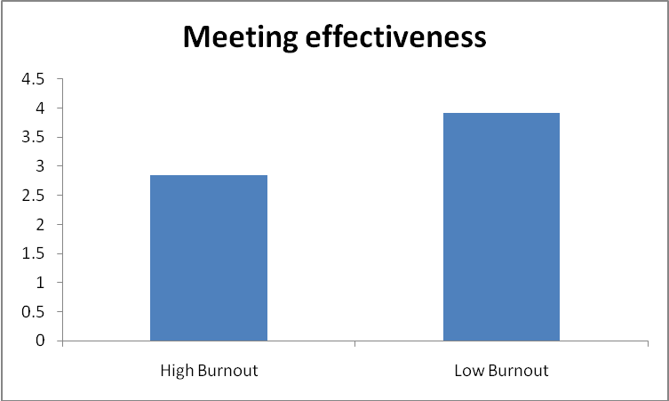
Problem Solving

Figure 2. Interpersonal trust differences between high and low burnout departments

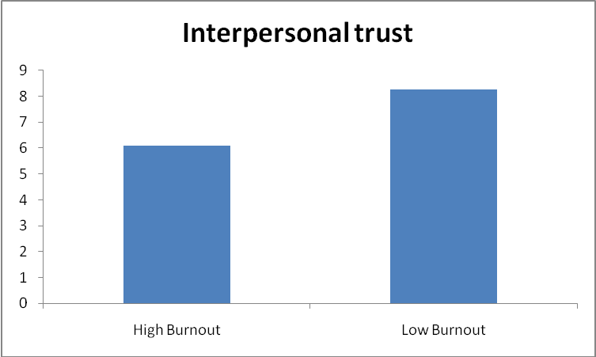
Figure 3. Goal setting differences between high and low burnout departments

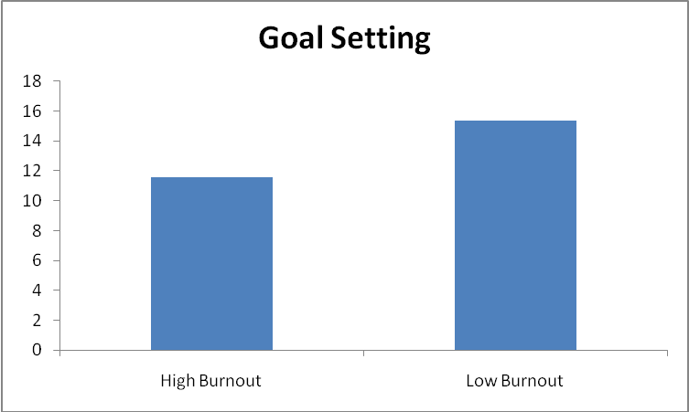
Figure 4. Department performance differences between high and low burnout departments

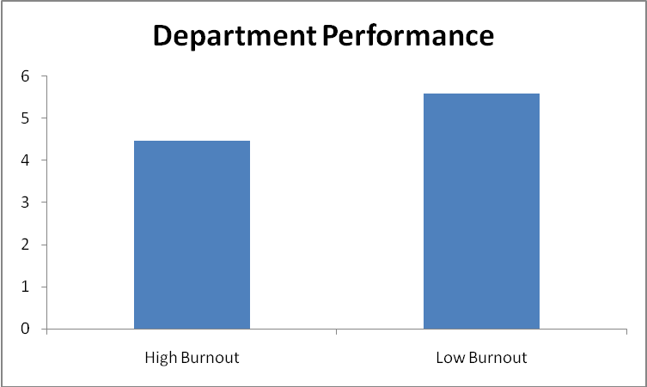
Figure 5. Recommended departmental burnout prevention/reduction tactics

